eBlessings International Daily Devotional Archives
enrich, inspire, encourage, bless, and empower spiritual warriors for end-time battles prepared with the guidance of the Holy Spirit for spiritual growth and victory! Devotionals Designed to Empower and Grow Our Spirits
JUNE 2009 JUNE 2009 JUNE 2009
Visit DOT, and WOW Empowerment Series, plus Prophecy, Spiritual Keys & Lessons, IA, PP and more...

Each One! Bless One!
You Make a Difference!

* * * * *

Pray to make those things in your life
which has power over you and yours to be powerless.

“And it came to pass, that, as he was praying in a certain place, when he ceased, one of his disciples said unto him, Lord, teach us to pray, as John also taught his disciples. And he said unto them, When ye pray, say, Our Father which art in heaven, Hallowed be thy name. Thy kingdom come. Thy will be done, as in heaven, so in earth. Give us day by day our daily bread. And forgive us our sins; for we also forgive every one that is indebted to us. And lead us not into temptation; but deliver us from evil.”
LUKE 11:1-4 (KJ)
M
ake Powerless Prayer - 3. Amen Holy Father! Emmanuel, we are asking You to right now make powerless-- evil television, evil radio, evil video games, pornography, gambling, slavery, usury, evil conversation, evil doers, evil dimensions, evil space, evil stars, evil planets, evil aliens, evil nephallim, evil corporations, evil businesses, evil companies, evil non-profits, evil magistrates, evil courts, evil judges, evil lawyers, evil police, evil sheriffs, evil jailers, evil probation officers, evil wardens, evil pardon and parole officers, evil institutions, evil internet usage, evil money usage, evil occupations, any evil creatures or entities and anything which our Heavenly Father created which evil has turned evil or to the service of evil-- known or unknown, disclosed or not disclosed, revealed or not revealed; and make powerless their replacements, and make powerless the replacements to the replacements and any replacements to come. And Lord Yeshua, Who many call Jesus, release to You for review and send on to Abba Father all the prayers, blessings, healings, and miracles of all the Saints which have been held, destroyed, stopped, delayed or held in any condition right now, and from now to the beginning of time and all time forward should any be attempted to be held, delayed, stopped or destroyed. In Your name Emmanuel, by the Power of Your Blood, by the Power of Your Crucifixion, Resurrection, Descendsion, and Ascension, thank You for making it so right now. We also ask that three (3) billion Holy Angels pray this prayer until its happens or until the Messiah says to stop praying it. We thank You Yeshua, Who we call Jesus, bless You Yeshua, and we praise You for it Messiah. Thank You Abba Father for this, we bless You Father God for this, and we praise You Yahweh, Most Omnipotent One! We love You! Amen! Holy Father!

MAKE POWERLESS PRAYER – 3
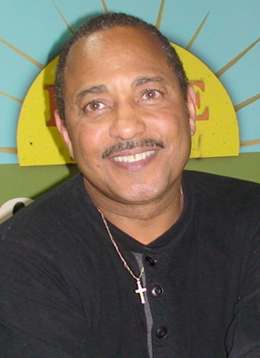
Bro. James Anthony Allen
Born-Again, Holy Ghost-filled
Tongue-speaking, Lion of Judah
Evangelist and US Patriot
http://www.eBlessings.us ; eBlessings@gmail.com
Stone Mountain, Georgia, USA, North America

